**1.6 IT Session**

1. Confirm or create GitHub logins.
2. Create a data warehouse project structure on their local system.
3. Upload your first SQL file and project structure to their GitHub repository.
4. Take four screenshots of your setup:
   * the root directory in GitHub

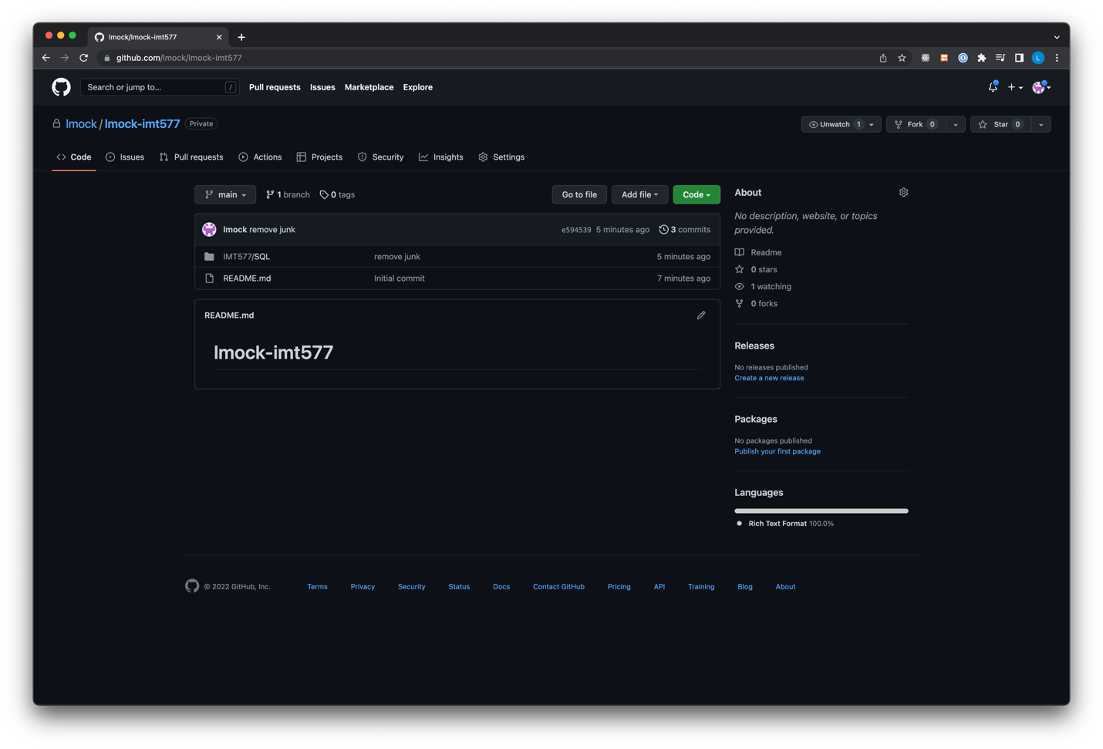

* + the course is set up on a system of their choice

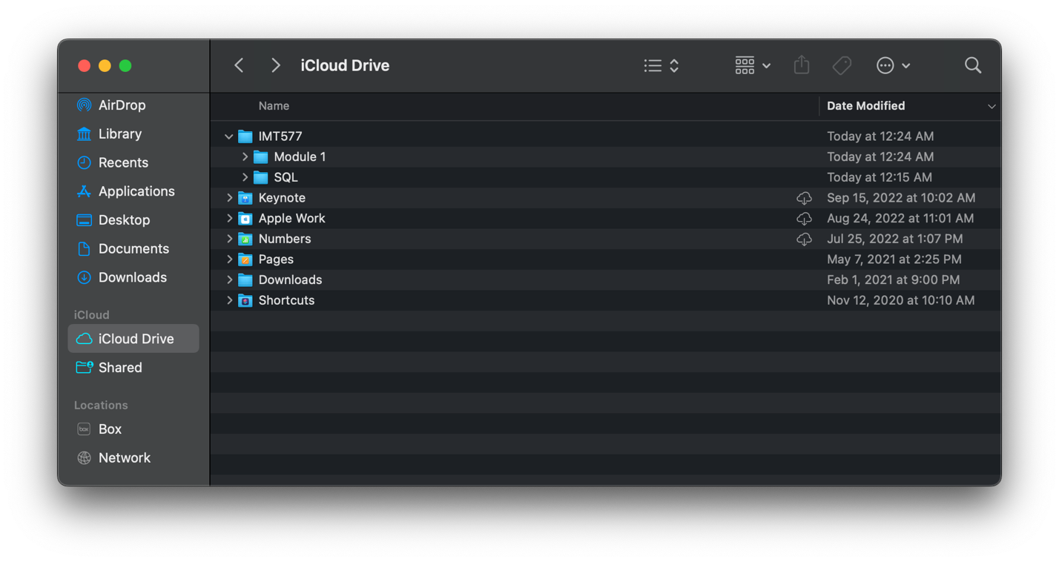

* + the SQL file in GitHub

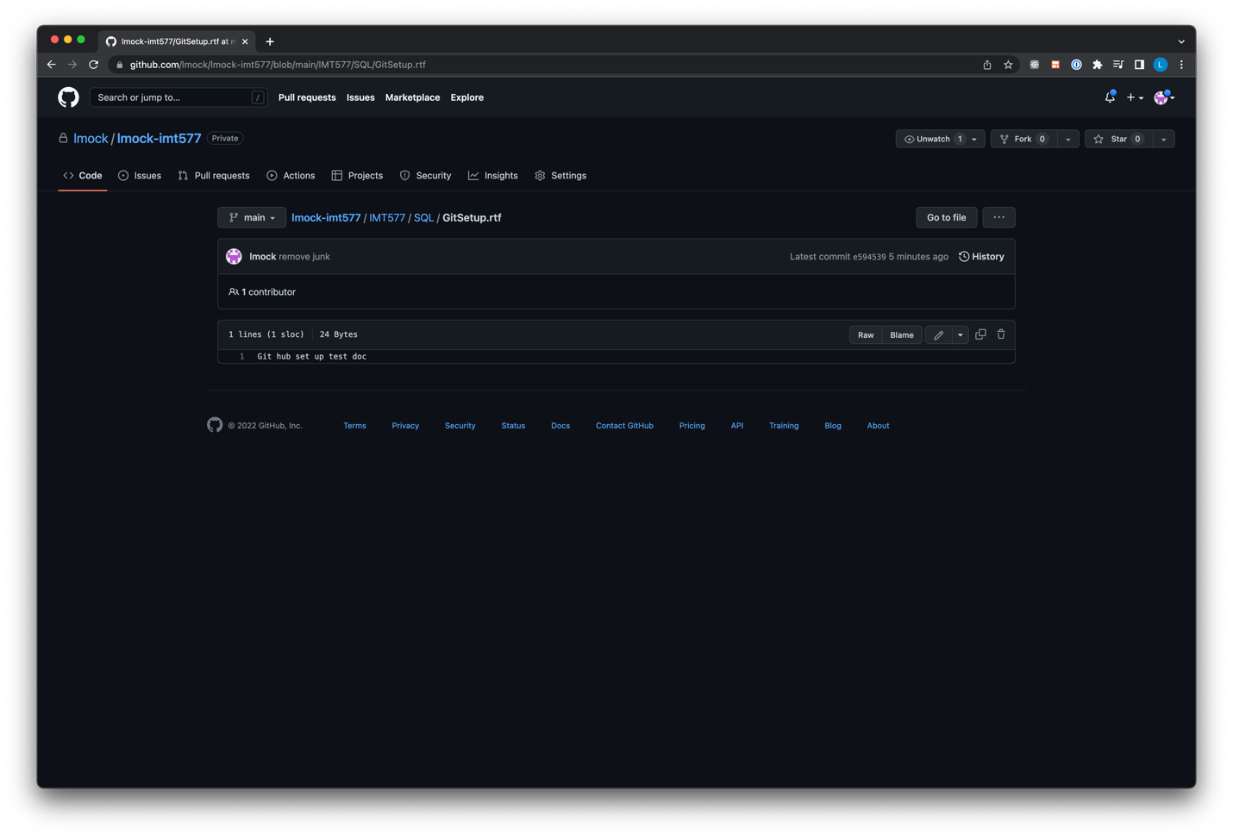

* + your security settings are private and have added the instructor and reader grader

